192373038
Shaik Suhel Basha

Knowledge Engineering And Data Science

LAB

EXPERIMENT 1: Data Exploration and Cleaning with pandas
Level: Simple | CO: CO3
AIM: Load, inspect, clean and summarise student marks, then draw three charts.
TOOLS: Python, pandas, matplotlib

Theory
pandas DataFrames store tabular data. Missing values can distort analysis. The median is robust to outliers, while the mean is affected by extreme values. Duplicate records can count the same student twice. Values outside a valid range, such as attendance above 100%, must be corrected or removed.

Procedure / Algorithm
1. Load student_marks.csv and inspect head, shape, info and describe.
2. Count missing values with isna().sum().
3. Replace impossible attendance with missing; fill numeric columns with median and categories with mode.
4. Remove duplicate rows and save student_marks_clean.csv.
5. Calculate final-exam statistics, department means and correlation.
6. Draw a histogram, box plot and scatter plot.

Complete Python Program

import pandas as pd
import matplotlib.pyplot as plt
from pathlib import Path
file = "student_marks.csv"
if not Path(file).exists():
data = {
"reg_no":["S1","S2","S3","S4","S5","S6","S6","S8"],
"department":["CSE","ECE","CSE","IT","ECE","CSE","CSE","IT"],
"gender":["F","M","F","M","F","M","M","F"],
"attendance":[90,80,95,75,None,140,140,88],
"internal":[25,20,28,18,22,24,24,19],
"final_exam":[78,65,88,55,72,81,81,60],
"study_hours":[5,3,7,2,4,6,6,3]}
pd.DataFrame(data).to_csv(file,index=False)
df=pd.read_csv(file)
print(df.head()); print("Shape:",df.shape)
df.info(); print(df.describe(include="all"))
print("Missing values:\n",df.isna().sum())
df.loc[~df.attendance.between(0,100),"attendance"]=pd.NA
for c in ["attendance","internal","final_exam","study_hours"]:
df[c]=df[c].fillna(df[c].median())
for c in ["department","gender"]:
df[c]=df[c].fillna(df[c].mode()[0])
df=df.drop_duplicates().copy()
df.to_csv("student_marks_clean.csv",index=False)
print("\nFinal exam statistics:\n",df.final_exam.agg(
["mean","median","std","min","max"]))
print("\nDepartment means:\n",df.groupby("department").final_exam.mean())
print("Study-hours correlation:",df.study_hours.corr(df.final_exam))
plt.figure()
plt.hist(df.final_exam,bins=5,edgecolor="black")
plt.xlabel("Final exam marks"); plt.ylabel("Students")
plt.title("Histogram of Final Exam Marks"); plt.show()
plt.figure()
df.boxplot(column="final_exam",by="department")
plt.xlabel("Department"); plt.ylabel("Final exam marks")
plt.title("Final Exam Marks by Department"); plt.suptitle(""); plt.show()
plt.figure()
plt.scatter(df.study_hours,df.final_exam)
plt.xlabel("Study hours"); plt.ylabel("Final exam marks")
plt.title("Study Hours vs Final Exam Marks"); plt.show()
Expected Output / Observation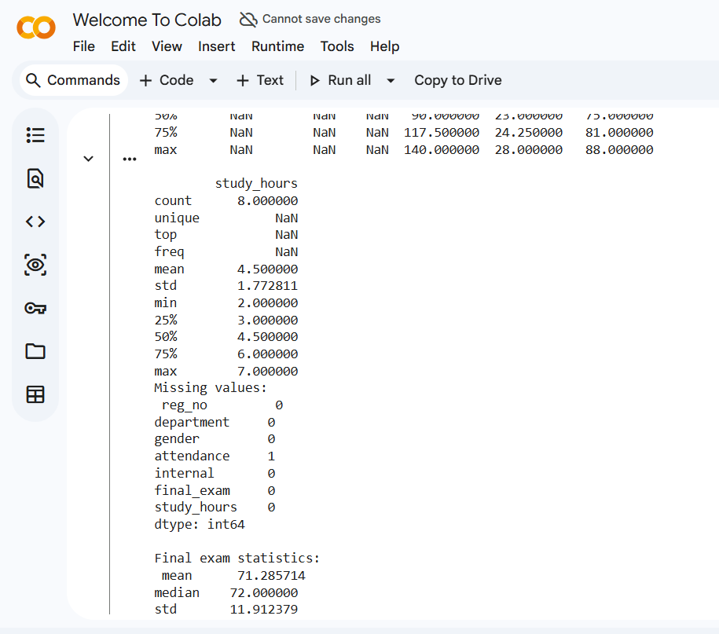
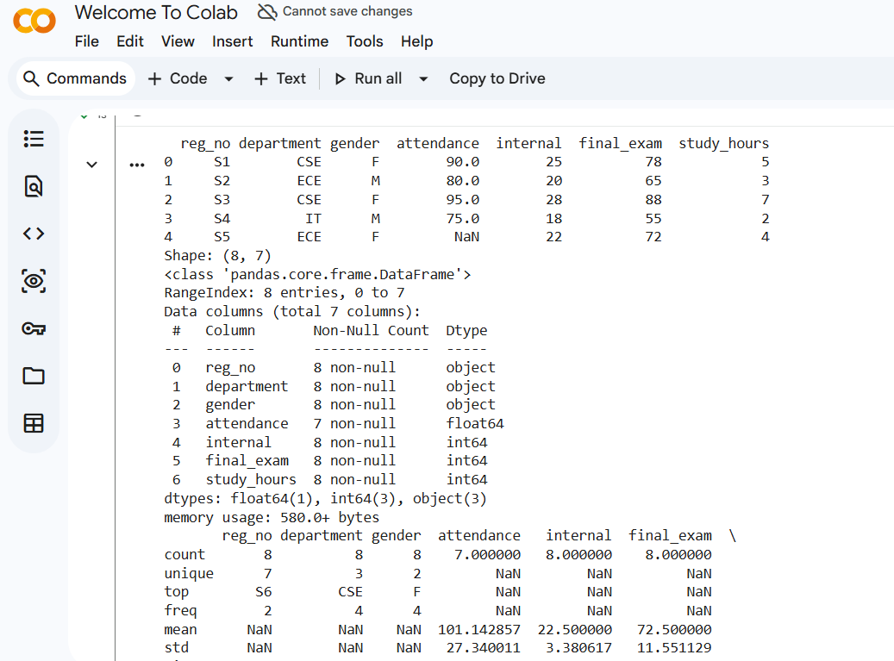

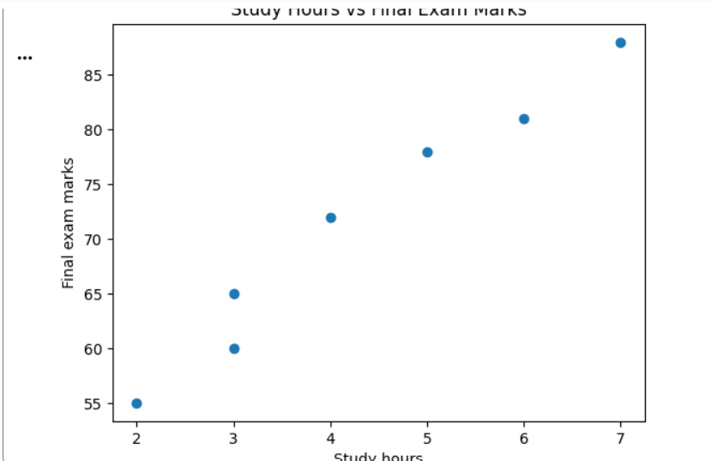

Result
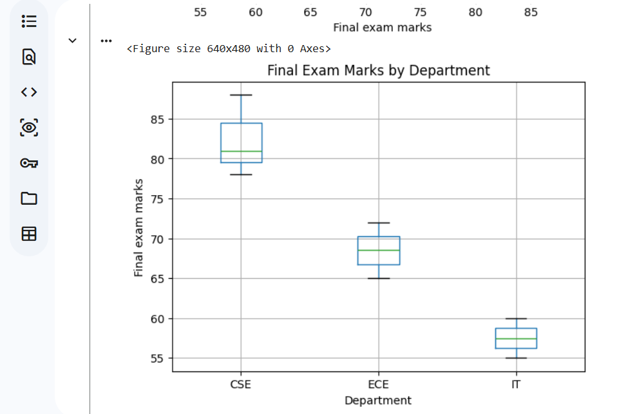
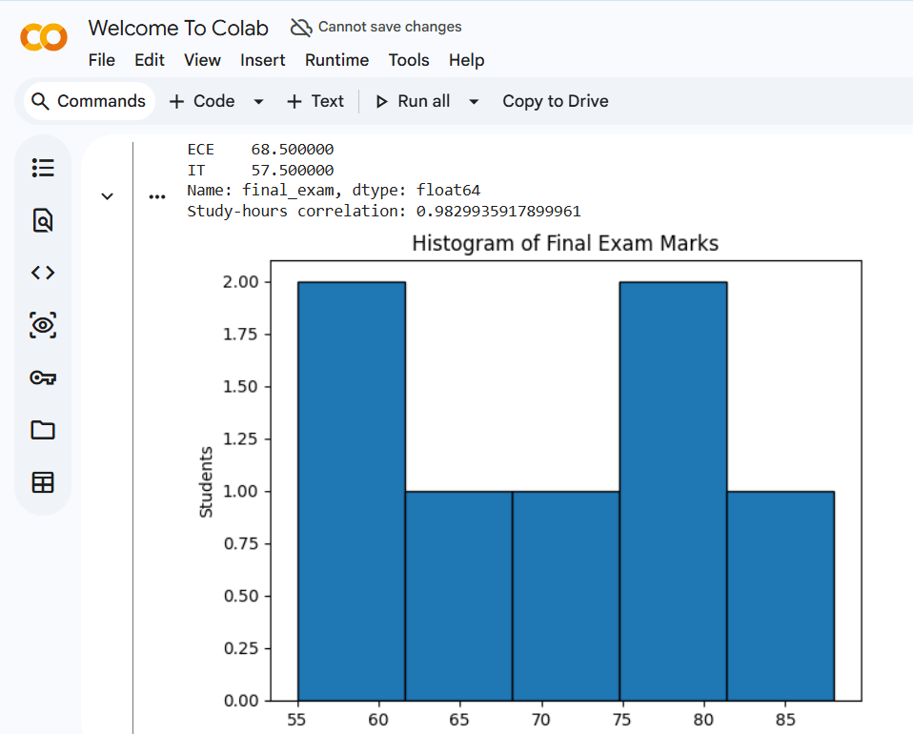
The student dataset was inspected and cleaned. Summary statistics, department means and correlation were calculated, and the

Viva Questions and Answers
Why is median better than mean when outliers exist?
Median is the middle value and is not pulled strongly by extreme values. Mean can be distorted by outliers.
What does correlation 0.7 tell you and not tell you?
It indicates a fairly strong positive linear association. It does not prove that study hours cause higher marks.
How did cleaning change the mean?
Removing duplicate rows changes the weight of repeated records; median imputation can also affect the mean. The exact change depends on the original data.

EXPERIMENT 2: Semantic Network and Inheritance Queries
Level: Simple | CO: CO1
AIM: Represent animal concepts as a directed semantic network and answer inheritance and path queries.
TOOLS: Python, NetworkX, Matplotlib

Theory
A semantic network stores concepts as nodes and relationships as labelled edges. A specific node inherits properties from a general parent. The algorithm checks local properties first, so a specific exception can override a general rule.

Procedure / Algorithm
1. Create nodes for Animal, Bird, Fish, Canary, Penguin and Tweety.
2. Add is-a and instance-of links.
3. Store properties such as can, has-part and colour.
4. Implement inheritance by checking the node before its parent.
5. Test five queries and find the path from Tweety to Animal.
6. Draw the labelled graph.

Complete Python Program
import networkx as nx
import matplotlib.pyplot as plt
G=nx.DiGraph()
G.add_edges_from([
("Bird","Animal",{"relation":"is-a"}),
("Fish","Animal",{"relation":"is-a"}),
("Canary","Bird",{"relation":"is-a"}),
("Penguin","Bird",{"relation":"is-a"}),
("Tweety","Canary",{"relation":"instance-of"})])
facts={
"Animal":{"can":"breathe"},
"Bird":{"can":"fly","has-part":"wings"},
"Fish":{"can":"swim"},
"Canary":{"colour":"yellow"},
"Penguin":{"can":"cannot fly"},
"Tweety":{"colour":"yellow"}}
def inherits(node,relation):
visited=set()
while node and node not in visited:
visited.add(node)
if relation in facts.get(node,{}):
return facts[node][relation],node
parents=list(G.successors(node))
node=parents[0] if parents else None
return None,None
for n,r in [("Tweety","can"),("Tweety","has-part"),
("Penguin","can"),("Canary","colour"),
("Tweety","colour")]:
print(n,r,"=",inherits(n,r))
print("Path:",nx.shortest_path(G,"Tweety","Animal"))
pos=nx.spring_layout(G,seed=4)
nx.draw(G,pos,with_labels=True,node_size=1800,
node_color="lightblue",arrows=True)
labels={(u,v):x["relation"] for u,v,x in G.edges(data=True)}
nx.draw_networkx_edge_labels(G,pos,edge_labels=labels)
plt.title("Animal Semantic Network"); plt.axis("off"); plt.show()

Expected Output / Observation
Tweety can = ('fly', 'Bird'); Tweety has-part = ('wings', 'Bird'); Penguin can = ('cannot fly', 'Penguin'); Canary colour = ('yellow', 'Canary'); Tweety colour = ('yellow', 'Tweety'). Path: Tweety → Canary → Bird → Animal.
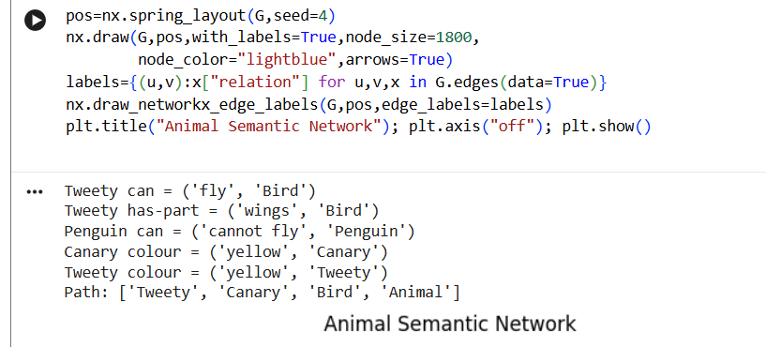

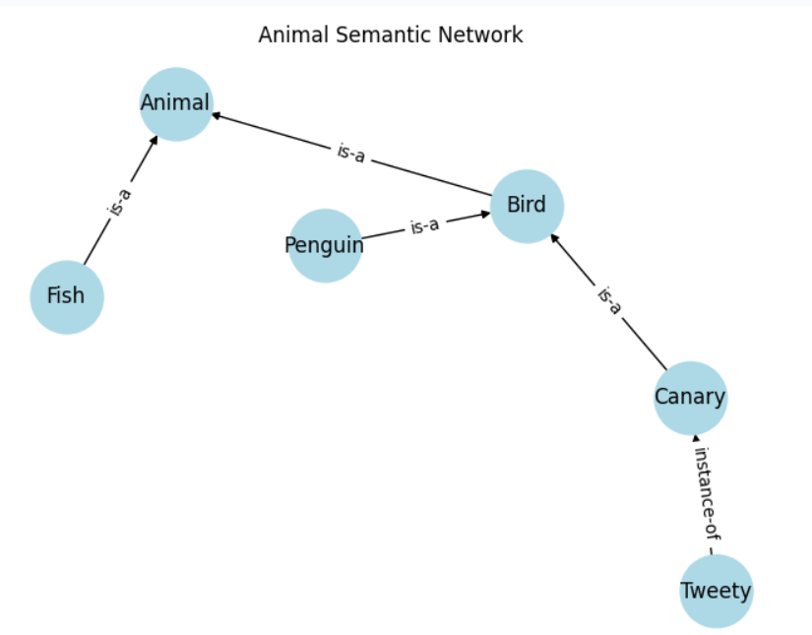

Result
The semantic network and inheritance function were implemented. The Penguin-specific value overrides the general Bird value.

Viva Questions and Answers
What is inheritance and why does it save storage?
A child node reuses properties stored at its parent instead of repeating them.
How does the function choose local or inherited values?
It checks the current node first, then follows parent links only when the value is absent.
What is difficult to express in a semantic network?
Complex logical constraints, quantified statements and detailed rules are difficult with simple links alone.

EXPERIMENT 3: Frames with Defaults, Inheritance and If-Needed Procedures
Level: Simple | CO: CO1
AIM: Implement frames with slots, defaults, inheritance and attached procedures.
TOOLS: Python classes and dictionaries

Theory
A frame represents an object or concept using slots. A slot can contain a stored value, default, or procedure that calculates a value when requested. A demon is a procedure automatically triggered by an update.

Procedure / Algorithm
1. Create a Frame class with name, parent and slot dictionary.
2. Implement add_slot, get_with_source, get and set.
3. Check stored value, if-needed procedure, default and parent in that order.
4. Create Vehicle, Car and MyCar frames.
5. Set wheels default to 4 and calculate mileage from odometer/fuel.
6. Trigger a warning demon by setting a negative mileage.

Complete Python Program
class Frame:
def __init__(self,name,parent=None):
self.name=name; self.parent=parent; self.slots={}
def add_slot(self,name,value=None,default=None,
if_needed=None,if_added=None):
self.slots[name]={"value":value,"default":default,
"if_needed":if_needed,"if_added":if_added}
def get_with_source(self,slot):
x=self.slots.get(slot)
if x:
if x["value"] is not None: return x["value"],self.name+" stored"
if x["if_needed"]: return x["if_needed"](self),self.name+" procedure"
if x["default"] is not None: return x["default"],self.name+" default"
if self.parent: return self.parent.get_with_source(slot)
return None,"not found"
def get(self,slot): return self.get_with_source(slot)[0]
def set(self,slot,value):
if slot not in self.slots: self.add_slot(slot)
demon=self.slots[slot]["if_added"]
if demon: demon(value)
self.slots[slot]["value"]=value
def mileage(f):
fuel=f.get("fuel_used")
return round(f.get("odometer")/fuel,2) if fuel else "Cannot calculate"
def warn(v):
if v<0: print("WARNING: mileage cannot be negative")
vehicle=Frame("Vehicle"); vehicle.add_slot("wheels",default=4)
vehicle.add_slot("fuel_type",default="Petrol")
car=Frame("Car",vehicle); car.add_slot("type",default="Car")
my=Frame("MyCar",car)
my.add_slot("brand",value="Toyota")
my.add_slot("odometer",value=12000)
my.add_slot("fuel_used",value=600)
my.add_slot("mileage",if_needed=mileage,if_added=warn)
for s in ["brand","wheels","fuel_type","type","odometer","fuel_used","mileage"]:
print(s,my.get_with_source(s))
my.set("mileage",-5)

Sample Output / Observation
brand ('Toyota', 'MyCar stored'); wheels (4, 'Vehicle default'); fuel_type ('Petrol', 'Vehicle default'); type ('Car', 'Car default'); mileage (20.0, 'MyCar procedure'); then WARNING: mileage cannot be negative.
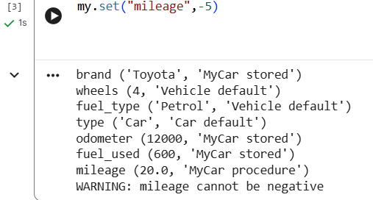

Result
The frame hierarchy returned stored, inherited, default and calculated values. The if-added demon fired for a negative mileage.

Viva Questions and Answers
How are frames similar to OOP classes?
Both group attributes and support inheritance. Frames additionally attach defaults and procedural actions to slots.
What is a default value?
A value used when no specific value has been stored.
When use an if-needed procedure?
When a value must be calculated from current data or should not be stored as a potentially outdated value.

EXPERIMENT 4: Rule-Based System with Forward Chaining
Level: Simple | CO: CO2
AIM: Build a production system that applies IF-THEN rules to facts using forward chaining.
TOOLS: Python

Theory
A production system has a rule base and working memory. A rule fires when all its conditions are present. Forward chaining is data-driven: it begins with facts and repeatedly adds conclusions. The conflict set contains all currently applicable rules.

Procedure / Algorithm
1. Store at least eight condition/conclusion pairs.
2. Create initial facts in a set.
3. Find rules whose conditions are satisfied and conclusions are new.
4. Choose one rule, add its conclusion and repeat.
5. Print the conflict set, fired rule and current facts each cycle.
6. Test approval, manual-review and rejection cases.
7. Compare first-match and most-specific-rule strategies.

Complete Python Program
rules=[
({"income_ok"},"income_verified"),
({"credit_good"},"credit_verified"),
({"income_verified","credit_verified"},"basic_eligible"),
({"basic_eligible","age_ok"},"age_verified"),
({"age_verified","documents_ok"},"documents_verified"),
({"documents_verified"},"loan_review"),
({"loan_review","collateral_ok"},"secured_eligible"),
({"loan_review","no_default"},"approve"),
({"existing_default"},"manual_review"),
({"low_income"},"reject")]
def forward(start,strategy="first"):
facts=set(start); cycle=1
while True:
conflict=[(i,c,out) for i,(c,out) in enumerate(rules,1)
if c<=facts and out not in facts]
if not conflict:
print("No rule can fire. STOP."); break
if strategy=="specific":
conflict.sort(key=lambda x:len(x[1]),reverse=True)
print("Cycle",cycle,"conflict set:",[(x[0],x[2]) for x in conflict])
chosen=conflict[0]; facts.add(chosen[2])
print("Fired:",chosen[0],"->",chosen[2])
print("Facts:",sorted(facts)); cycle+=1
print("Final facts:",sorted(facts))
case1={"income_ok","credit_good","age_ok","documents_ok",
"collateral_ok","no_default"}
forward(case1,"first")
forward(case1,"specific")
forward({"existing_default"})
forward({"low_income"})

Sample Output / Observation
Case 1 derives approval-related facts; case 2 derives manual_review; case 3 derives reject. Each run stops when no new conclusion can be added. The exact cycle order depends on conflict strategy.
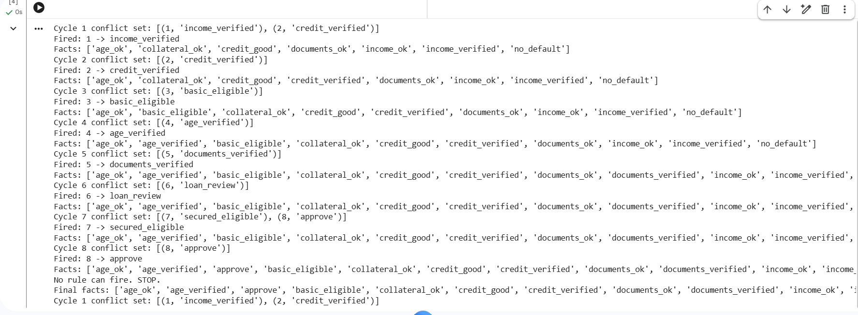

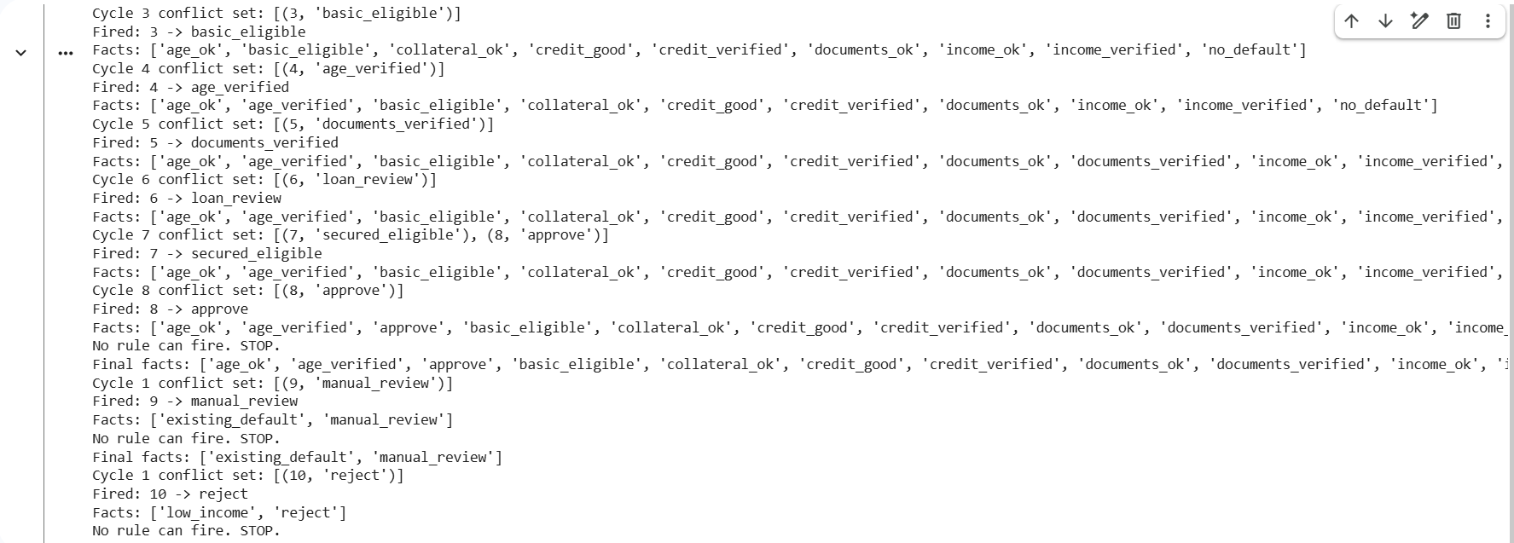

Result
The forward-chaining engine was implemented with ten rules and tested on three initial fact sets using two conflict-resolution strategies.

Viva Questions and Answers
What is a conflict set?
The set of rules whose conditions are satisfied at the current cycle.
Why does the loop stop?
It stops when no applicable rule can add a new fact.
Forward vs backward chaining?
Forward chaining starts with facts and derives conclusions; backward chaining starts with a goal and searches for supporting facts.

EXPERIMENT 5: Backward Chaining with Why/How Explanation
Level: Medium | CO: CO2
AIM: Implement goal-driven reasoning that asks for missing observations and explains its proof.
TOOLS: Python

Theory
Backward chaining starts with a goal, finds rules that can prove it, and recursively checks their conditions. If a condition is an unknown observation, the system asks the user. Why explains the purpose of a question; How displays the proof chain.

Procedure / Algorithm
1. Define at least twelve rules with IDs, conditions and conclusions.
2. Store facts as True/False.
3. Write recursive prove(goal).
4. Ask only for basic observations and cache answers.
5. Accept why to explain why an observation is needed.
6. Print proof rules and questions asked.
7. Run consultations for different goals and a goal that cannot be proved.

Complete Python Program
rules=[
("R1",["yellow","wet_soil"],"overwatering"),
("R2",["yellow","dry_soil"],"underwatering"),
("R3",["spots","humid"],"fungal_disease"),
("R4",["spots","dry_air"],"leaf_scorch"),
("R5",["white_powder","humid"],"powdery_mildew"),
("R6",["wilting","dry_soil"],"underwatering"),
("R7",["wilting","wet_soil"],"root_rot_risk"),
("R8",["root_rot_risk","bad_smell"],"root_rot"),
("R9",["fungal_disease","spreading"],"fungal_infection"),
("R10",["powdery_mildew"],"fungal_issue"),
("R11",["underwatering","dry_pot"],"water_needed"),
("R12",["overwatering","yellow"],"reduce_watering"),
("R13",["leaf_scorch","strong_sun"],"move_to_shade"),
("R14",["fungal_infection","no_growth"],"urgent_review")]
askable={"yellow","wet_soil","dry_soil","spots","humid","dry_air",
"white_powder","wilting","bad_smell","spreading",
"dry_pot","strong_sun","no_growth"}
facts={}; asked=set(); proof=[]
def prove(goal,trail=None):
if goal in facts: return facts[goal]
if trail is None: trail=set()
if goal in trail: return False
if goal in askable:
print("WHY: this observation is needed to test a rule for",goal)
if goal not in asked:
ans=input("Is "+goal+" present? (yes/no/why): ").lower().strip()
while ans=="why":
print("WHY: a rule leading to the requested goal requires",goal)
ans=input("Answer yes/no: ").lower().strip()
facts[goal]=ans in ("yes","y"); asked.add(goal)
return facts[goal]
for rid,conditions,conclusion in rules:
if conclusion==goal and all(prove(c,trail|{goal}) for c in conditions):
proof.append((rid,conditions,conclusion)); facts[goal]=True
return True
return False
def consult(goal):
global facts,asked,proof
facts={}; asked=set(); proof=[]
print("\nGOAL:",goal)
ok=prove(goal)
print("CONCLUSION:",goal if ok else "Not proven")
print("HOW:",proof if proof else "No proof chain")
print("Questions asked:",len(asked))
if __name__=="__main__":
consult("overwatering")
# Run again with consult("underwatering"), consult("fungal_disease"),
# consult("root_rot") or consult("unknown_goal").

Sample Output / Observation
Example: for goal overwatering, answer yes to yellow and wet_soil. The system concludes overwatering and prints R1: IF yellow AND wet_soil THEN overwatering. Two observations were asked. User answers determine the result.
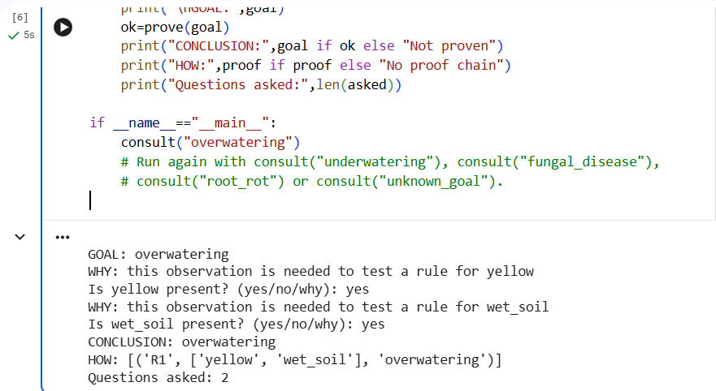

Result
The backward-chaining system uses fourteen rules, recursive goal proving, stored answers and Why/How explanations. It reports when a goal cannot be proved.

Viva Questions and Answers
Why is backward chaining suitable for consultation?
It focuses on the requested conclusion and asks only for observations relevant to that goal.
How does it avoid asking the same question twice?
It stores answers in the facts dictionary and tracks asked observations.
How does explanation improve trust?
It shows why information was requested and which rules and facts support the conclusion.

EXPERIMENT 6: Building and Reasoning over an Ontology
Level: Medium | CO: CO1
AIM: Create a university ontology with classes, properties, individuals and logical restrictions.
TOOLS: Protégé with HermiT, or Python owlready2

Theory
An ontology formally describes domain concepts and relationships. Classes represent categories, individuals are instances, object properties connect individuals and data properties store literal values. A reasoner checks consistency and infers facts from logical axioms.

Procedure / Algorithm
1. Write five competency questions.
2. Create at least eight classes and a hierarchy.
3. Define object properties with domain and range and data properties.
4. Declare Student and Faculty disjoint; require courses to have teachers.
5. Create at least ten individuals.
6. Save university.owl and run HermiT.
7. Assert one person as both Student and Faculty to demonstrate inconsistency.
8. Answer competency questions using DL Query or SPARQL.

Complete Python Program
from owlready2 import *
onto=get_ontology("http://example.org/university.owl")
with onto:
class Person(Thing): pass
class Student(Person): pass
class Faculty(Person): pass
class Undergraduate(Student): pass
class Postgraduate(Student): pass
class Course(Thing): pass
class Department(Thing): pass
class ResearchScholar(Postgraduate): pass
AllDisjoint([Student,Faculty])
class enrolledIn(ObjectProperty):
domain=[Student]; range=[Course]
class teaches(ObjectProperty):
domain=[Faculty]; range=[Course]
class belongsTo(ObjectProperty):
domain=[Person]; range=[Department]
class hasName(DataProperty,FunctionalProperty):
domain=[Person]; range=[str]
class hasCredits(DataProperty,FunctionalProperty):
domain=[Course]; range=[int]
class hasTeacher(ObjectProperty):
domain=[Course]; range=[Faculty]
Course.is_a.append(hasTeacher.some(Faculty))
cs=Department("CSE")
ai=Course("AI_Course"); ai.hasCredits=4
networks=Course("Networks"); networks.hasCredits=3
teacher=Faculty("Dr_Ravi"); teacher.hasName="Dr Ravi"
teacher.teaches=[ai,networks]
ai.hasTeacher=[teacher]; networks.hasTeacher=[teacher]
asha=Undergraduate("Asha"); asha.hasName="Asha"
asha.enrolledIn=[ai]; asha.belongsTo=[cs]
for i in range(1,9):
st=Student("Student_"+str(i))
st.hasName="Student "+str(i)
st.enrolledIn=[ai if i%2 else networks]
st.belongsTo=[cs]
onto.save(file="university.owl",format="rdfxml")
print("Saved university.owl")
print("Asha courses:",[x.name for x in onto.Asha.enrolledIn])
try:
with onto: sync_reasoner()
print("Reasoner completed.")
except Exception as e:
print("Reasoner/Java setup issue:",e)
# Demonstrate inconsistency in a separate run:
# onto.Asha.is_a.append(onto.Faculty)
# with onto: sync_reasoner()

Sample Output / Observation
Saved university.owl. Asha courses: ['AI_Course']. The reasoner checks the ontology. If Asha is additionally asserted as Faculty, the Student/Faculty disjointness axiom makes the ontology inconsistent. HermiT may require a compatible Java installation.
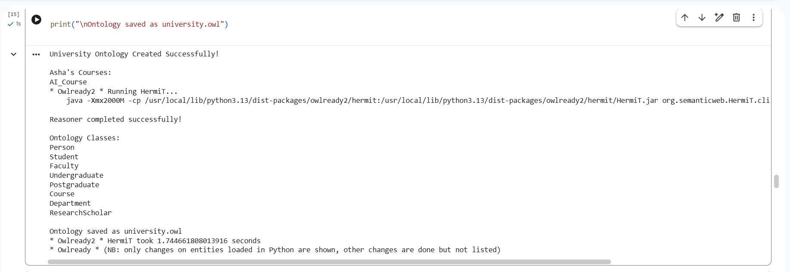

Result
The university ontology was created and saved. Classes, properties, restrictions and individuals were defined; reasoner output can be recorded after running HermiT.

Viva Questions and Answers
Ontology vs taxonomy and database schema?
A taxonomy is mainly a hierarchy. A database schema defines data structure. An ontology also defines formal meanings and logical axioms for reasoning.
What are domain and range?
Domain specifies the subject class of a property; range specifies the object class or datatype.
Which questions cannot be answered?
Questions needing facts that were neither entered nor logically inferable cannot be answered.

EXPERIMENT 7: Building and Querying a Knowledge Graph
Level: Medium | CO: CO1
AIM: Convert CSV records to RDF triples, resolve duplicate entities, query and visualise a knowledge graph.
TOOLS: Python, pandas, rdflib, NetworkX, Matplotlib

Theory
An RDF triple is subject–predicate–object. A knowledge graph links entities through relationships. Entity resolution identifies records that refer to the same real-world entity. SPARQL retrieves information from RDF graphs.

Procedure / Algorithm
1. Create people.csv and works.csv.
2. Define namespace, classes and properties.
3. Convert rows into RDF triples.
4. Compare names within departments using SequenceMatcher.
5. Merge duplicate person URIs.
6. Run five SPARQL queries, compute degree and draw the graph.
7. Save the graph as Turtle.

Complete Python Program
import pandas as pd, difflib, networkx as nx, matplotlib.pyplot as plt
from rdflib import Graph,Namespace,RDF,Literal
EX=Namespace("http://example.org/u/")
people=pd.DataFrame([
["P1","Asha","CSE","Chennai"],["P2","A. Kumar","IT","Chennai"],
["P3","Arun Kumar","IT","Chennai"],["P4","Meera","ECE","Madurai"],
["P5","Ravi","CSE","Coimbatore"]],
columns=["id","name","dept","city"])
works=pd.DataFrame([
["P1","Project Alpha","Developer"],["P2","Project Beta","Analyst"],
["P3","Project Gamma","Developer"],["P4","Project Alpha","Tester"],
["P5","Project Delta","Lead"]],columns=["id","project","role"])
people.to_csv("people.csv",index=False); works.to_csv("works.csv",index=False)
g=Graph(); g.bind("ex",EX)
for _,r in people.iterrows():
person=EX[r.id]
g.add((person,RDF.type,EX.Person))
g.add((person,EX.name,Literal(r["name"])))
g.add((person,EX.memberOf,EX[r.dept]))
g.add((person,EX.livesIn,EX[r.city]))
for _,r in works.iterrows():
g.add((EX[r.id],EX.worksOn,EX[r.project.replace(" ","_")]))
g.add((EX[r.id],EX.role,Literal(r.role)))
# Find similar names in the same department.
for i in range(len(people)):
for j in range(i+1,len(people)):
a,b=people.iloc[i],people.iloc[j]
score=difflib.SequenceMatcher(None,
a["name"].lower().replace(".",""),
b["name"].lower()).ratio()
if a.dept==b.dept and score>=0.55:
print("Possible duplicate:",a["name"],b["name"],score)
# Merge P3 into P2 by redirecting subject triples.
old,new=EX[b.id],EX[a.id]
for s,p,o in list(g.triples((old,None,None))):
g.remove((s,p,o)); g.add((new,p,o))
break
g.serialize("knowledge_graph.ttl",format="turtle")
q="""PREFIX ex: <http://example.org/u/>
SELECT ?person WHERE {?person ex:worksOn ex:Project_Alpha .}"""
print("Project Alpha query:",list(g.query(q)))
G=nx.DiGraph()
for s,p,o in g: G.add_edge(str(s).split("/")[-1],str(o).split("/")[-1])
print("Triples:",len(g),"Most connected:",max(G.degree,key=lambda x:x[1]))
pos=nx.spring_layout(G,seed=2)
nx.draw(G,pos,with_labels=True,node_size=900,font_size=7,arrows=True)
plt.title("University Knowledge Graph"); plt.show()

Sample Output / Observation
Creates people.csv, works.csv and knowledge_graph.ttl; prints a possible duplicate candidate, Project Alpha query results, triple count and most-connected node; displays a graph. Similarity-based merging is only a candidate and needs human review.
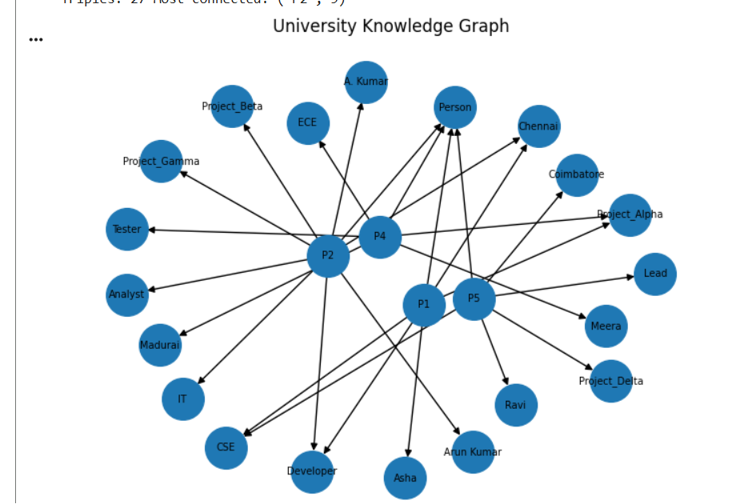

Result
The RDF graph was constructed, duplicate candidates were identified, a SPARQL query was executed, node degree was calculated and the graph was saved and visualised.

Viva Questions and Answers
What is a triple?
A subject, predicate and object statement, such as Asha–worksOn–Project Alpha.
Why is entity resolution necessary?
It prevents one entity being represented multiple times because of spelling differences.
How can an ontology improve the graph?
It defines valid classes, properties, meanings and constraints.

EXPERIMENT 8: Hypothesis Testing, ANOVA and Chi-Square
Level: Medium | CO: CO4
AIM: Apply t-tests, ANOVA and chi-square tests, interpret p-values and calculate a confidence interval.
TOOLS: Python, SciPy, pandas, Matplotlib

Theory
Hypothesis testing evaluates a claim using sample data. H0 is the null hypothesis and H1 is the alternative. A p-value measures how unusual the observed result would be if H0 were true. At alpha=0.05, reject H0 when p<0.05. Statistical significance does not automatically imply practical importance.

Procedure / Algorithm
1. Load exam_scores.csv or generate sample data.
2. State H0 and H1 for every test.
3. Run one-sample, independent and paired t-tests.
4. Run one-way ANOVA for methods A, B and C.
5. Run chi-square test between gender and result.
6. Print statistic, p-value, decision and conclusion.
7. Calculate a 95% confidence interval and draw a box plot.

Complete Python Program
import numpy as np, pandas as pd, matplotlib.pyplot as plt
from scipy import stats
from pathlib import Path
np.random.seed(10)
if not Path("exam_scores.csv").exists():
rows=[]
for i in range(90):
m=["A","B","C"][i%3]; before=np.random.normal(50,8)
after=before+{"A":7,"B":12,"C":16}[m]+np.random.normal(0,4)
gender="F" if i%2==0 else "M"
rows.append([i+1,m,before,after,gender,"Pass" if after>=60 else "Fail"])
pd.DataFrame(rows,columns=["student","method","score_before",
"score_after","gender","result"]).to_csv("exam_scores.csv",index=False)
df=pd.read_csv("exam_scores.csv"); alpha=.05
def report(name,test,h0,h1):
stat,p=test
print(name,"statistic=",round(stat,3),"p=",round(p,5),
"Decision:", "Reject H0" if p<alpha else "Fail to reject H0")
print("H0:",h0,"| H1:",h1)
report("One sample",stats.ttest_1samp(df.score_after,60),
"mean=60","mean differs from 60")
a=df[df.method=="A"].score_after; b=df[df.method=="B"].score_after
report("Independent",stats.ttest_ind(a,b,equal_var=False),
"A mean=B mean","A mean differs from B")
report("Paired",stats.ttest_rel(df.score_before,df.score_after),
"mean change=0","mean change differs from 0")
groups=[df[df.method==m].score_after for m in ["A","B","C"]]
report("ANOVA",stats.f_oneway(*groups),
"all three means equal","at least one mean differs")
tab=pd.crosstab(df.gender,df.result)
chi,p,dof,expected=stats.chi2_contingency(tab)
report("Chi-square",(chi,p),"gender and result independent",
"gender and result associated")
mean=df.score_after.mean(); sem=stats.sem(df.score_after)
print("95% CI:",stats.t.interval(.95,len(df)-1,loc=mean,scale=sem))
print("Method means:",df.groupby("method").score_after.mean())
df.boxplot(column="score_after",by="method")
plt.xlabel("Method"); plt.ylabel("Score after")
plt.title("Scores by Teaching Method"); plt.suptitle(""); plt.show()

Sample Output / Observation
Prints five test statistics and p-values, decisions at alpha=0.05, a 95% confidence interval, method means and a labelled box plot. Exact values are reproducible from the fixed random seed unless the supplied CSV is used.
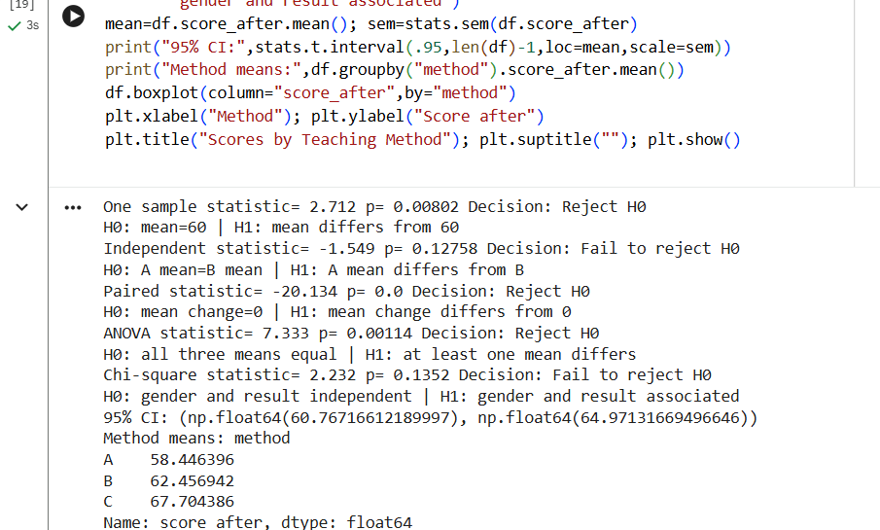

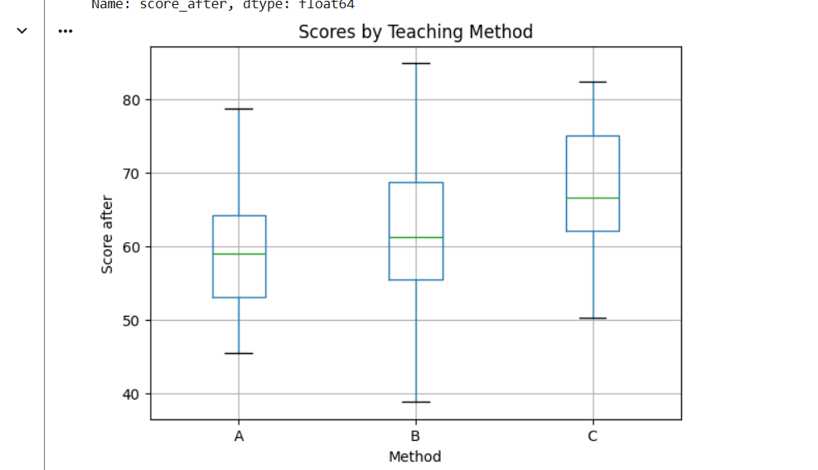

Result
The statistical tests and confidence interval were calculated. Conclusions were stated using the 0.05 significance level and the method distributions were visualised.

Viva Questions and Answers
What does p=0.03 mean?
Assuming H0 is true, data this extreme or more extreme would have probability 0.03 under the test assumptions. It is not the probability that H0 is true.
Why use ANOVA instead of many t-tests?
ANOVA compares several means in one overall test and avoids inflating Type I error through many pairwise tests.
If p=0.07 at alpha 0.05?
Fail to reject H0. Evidence is insufficient at this significance level; it does not prove H0 true.

EXPERIMENT 9: Acquiring Rules from Data with Decision Trees
Level: Hard | CO: CO5
AIM: Train and evaluate decision trees, extract IF-THEN rules and compare them with baseline and expert rules.
TOOLS: Python, scikit-learn, pandas, Matplotlib

Theory
A decision tree learns feature tests from labelled examples. Each path from root to leaf forms an IF-THEN rule. Training accuracy measures fit on training data; test accuracy estimates generalisation. Cross-validation repeats evaluation on different folds. A large train-test gap suggests overfitting.

Procedure / Algorithm
1. Load the Breast Cancer dataset.
2. Split 70:30 with stratification and fixed random seed.
3. Evaluate majority-class baseline and expert-style rules.
4. Train trees with depths 2, 3, 4 and 6.
5. Record train, test and five-fold cross-validation accuracy.
6. Select depth using validation evidence and print export_text output.
7. Calculate confusion matrix, precision, recall and F1.
8. Plot accuracy versus depth and discuss overfitting.

Complete Python Program
import numpy as np, pandas as pd, matplotlib.pyplot as plt
from sklearn.datasets import load_breast_cancer
from sklearn.model_selection import train_test_split,cross_val_score
from sklearn.tree import DecisionTreeClassifier,export_text
from sklearn.metrics import *
data=load_breast_cancer(as_frame=True); X=data.data; y=data.target
Xtr,Xte,ytr,yte=train_test_split(X,y,test_size=.30,
random_state=42,stratify=y)
base=np.full(len(yte),ytr.mode()[0])
print("Baseline accuracy:",accuracy_score(yte,base))
def expert(X):
return np.array([0 if (r["worst radius"]>16.5 or
r["worst concave points"]>.15) else 1
for _,r in X.iterrows()])
ep=expert(Xte)
print("Expert accuracy:",accuracy_score(yte,ep))
rows=[]; models={}
for depth in [2,3,4,6]:
model=DecisionTreeClassifier(max_depth=depth,random_state=42)
model.fit(Xtr,ytr); models[depth]=model
pred=model.predict(Xte)
cv=cross_val_score(model,Xtr,ytr,cv=5).mean()
rows.append([depth,accuracy_score(ytr,model.predict(Xtr)),
accuracy_score(yte,pred),cv])
print("Depth",depth,"CM:\n",confusion_matrix(yte,pred))
print("Precision/Recall/F1:",
precision_score(yte,pred),recall_score(yte,pred),f1_score(yte,pred))
table=pd.DataFrame(rows,columns=["Depth","Train","Test","CV"])
print(table)
best_depth=int(table.loc[table.CV.idxmax(),"Depth"])
best=models[best_depth]
print("Selected depth:",best_depth)
print(export_text(best,feature_names=list(X.columns)))
pred=best.predict(Xte)
print("Tree metrics:",precision_score(yte,pred),
recall_score(yte,pred),f1_score(yte,pred))
plt.plot(table.Depth,table.Train,marker="o",label="Train")
plt.plot(table.Depth,table.Test,marker="s",label="Test")
plt.plot(table.Depth,table.CV,marker="^",label="5-fold CV")
plt.xlabel("Tree depth"); plt.ylabel("Accuracy")
plt.title("Accuracy versus Tree Depth"); plt.legend(); plt.show()

Sample Output / Observation
Prints majority baseline, expert-rule score, depth-wise training/test/CV scores, confusion matrices, precision/recall/F1, and the selected tree's IF-THEN splits. It also displays the accuracy-depth graph. Values are generated by scikit-learn at runtime.
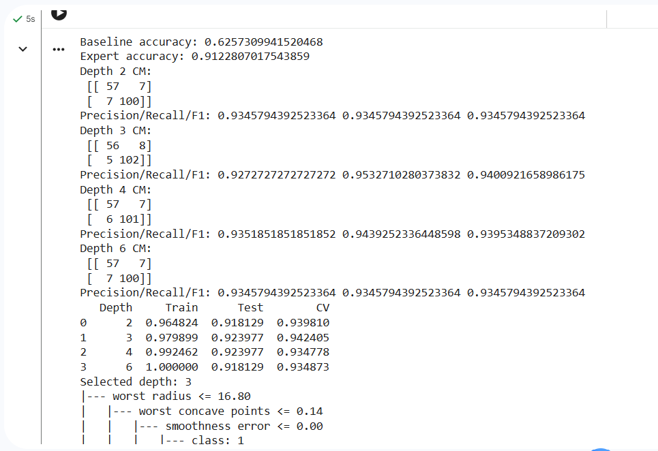
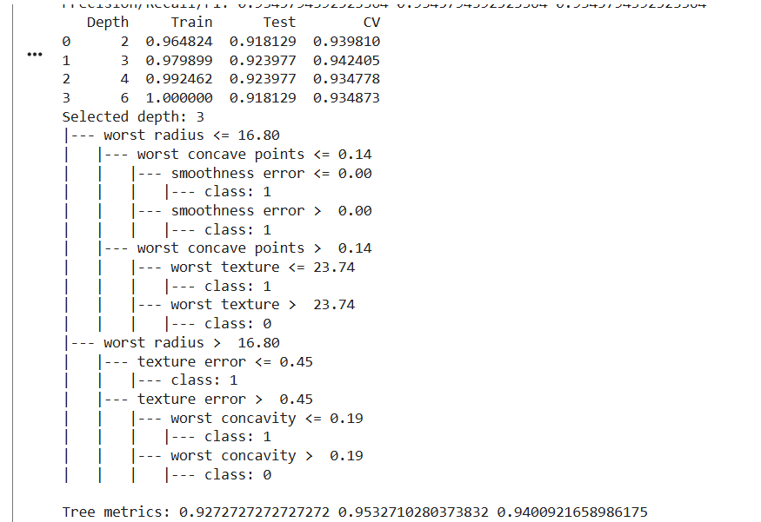

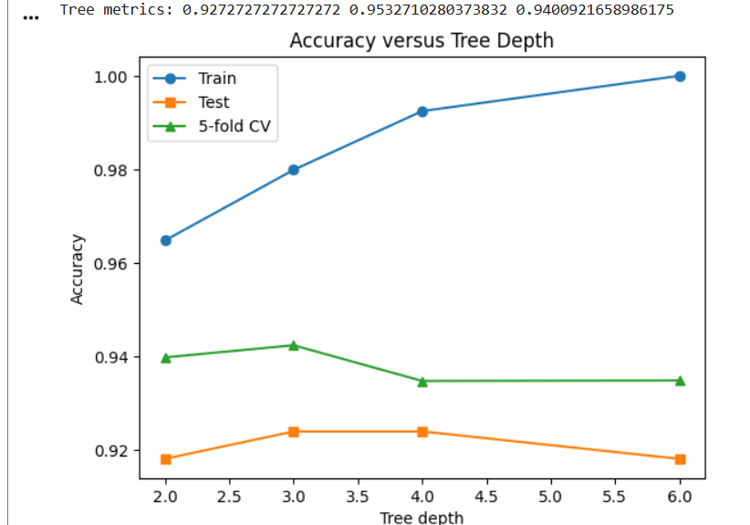

Result
The decision tree was trained and compared at four depth limits. The best depth was selected using cross-validation, and its rules and classification metrics were reported.

Viva Questions and Answers
Why can a deep tree overfit?
It can memorise noise and individual training examples, leading to poor performance on unseen data.
Why can accuracy mislead on imbalanced data?
A majority-only classifier may score well while missing minority cases. Precision, recall, F1 and confusion matrix add information.
How present rules to an expert?
Show IF-THEN conditions, supporting examples, error rates and failure cases for domain review.
Advantages and risks of learned rules?
They discover patterns from data, but may be biased, unstable, overfit or difficult to interpret when complex.

EXPERIMENT 10: Hybrid Decision-Support System: Knowledge Graph, Rules and ML
Level: Hard | CO: CO1, CO2, CO5
AIM: Build an educational IT help-desk prototype combining a knowledge graph, certainty-factor rules and a classifier.
TOOLS: Python, pandas, NetworkX, scikit-learn

Theory
A hybrid system combines structured graph knowledge, explicit expert rules and machine-learning predictions. Rules produce conclusions with certainty factors; the classifier provides a second opinion. A combination policy defines which component wins when they disagree. This sample uses synthetic data and is not validated for real IT operations.

Procedure / Algorithm
1. Choose IT help-desk routing: Network, Hardware or Software.
2. Create at least 40 graph relationships.
3. Create at least ten certainty-factor rules, including negative evidence.
4. Train a classifier on at least 100 labelled records.
5. Report five-fold cross-validation.
6. Define hybrid logic: strong rule evidence takes priority; otherwise use ML.
7. Compare baseline, rules-only, model-only and hybrid on the same test set.
8. Print five explanations and analyse a failure case.

Complete Python Program
import numpy as np, pandas as pd, networkx as nx
from sklearn.datasets import make_classification
from sklearn.model_selection import train_test_split,cross_val_score
from sklearn.ensemble import RandomForestClassifier
from sklearn.dummy import DummyClassifier
from sklearn.metrics import accuracy_score,f1_score
cols=["wifi","cpu","disk","app","packet","age"]
X,y=make_classification(n_samples=300,n_features=6,n_informative=5,
n_redundant=0,n_classes=3,n_clusters_per_class=1,random_state=21)
X=pd.DataFrame(X,columns=cols)
Xt,Xv,yt,yv=train_test_split(X,y,test_size=.30,random_state=21,stratify=y)
model=RandomForestClassifier(n_estimators=100,random_state=21)
model.fit(Xt,yt)
print("5-fold CV:",cross_val_score(model,Xt,yt,cv=5).mean())
# Knowledge graph with more than 40 illustrative relationships.
KG=nx.DiGraph()
nodes=["Network","Hardware","Software","WiFi","Router","PacketLoss",
"CPU","Disk","Application","Driver","Restart","Cable","Update"]
KG.add_nodes_from(nodes)
for i,a in enumerate(nodes):
for j in range(1,5):
KG.add_edge(a,nodes[(i+j)%len(nodes)],relation="related")
print("Graph triples/edges:",KG.number_of_edges())
rules=[
({"wifi_low","packet_high"},"Network",.90),
({"router_down"},"Network",.85),
({"disk_error"},"Hardware",.90),
({"cpu_hot"},"Hardware",.80),
({"no_power"},"Hardware",.95),
({"app_crash"},"Software",.85),
({"update_failed"},"Software",.80),
({"driver_error"},"Software",.75),
({"wifi_low","router_ok"},"Network",.45),
({"app_crash","disk_error"},"Software",.55),
({"app_crash","recovered"},"Software",.30),
({"app_crash","recovered"},"NOT_Software",.60)]
def scores(facts):
result={}; fired=[]
for cond,label,cf in rules:
if cond<=facts:
fired.append((cond,label,cf))
key=label.replace("NOT_","")
result[key]=result.get(key,0)+(-cf if label.startswith("NOT_") else cf)
return result,fired
def makefacts(r):
f=set()
if r.wifi<-.3:f.add("wifi_low")
if r.packet>.3:f.add("packet_high")
if r.disk>.3:f.add("disk_error")
if r.cpu>.3:f.add("cpu_hot")
if r.app>.3:f.add("app_crash")
return f
labels={"Network":0,"Hardware":1,"Software":2}
def rule_pred(r):
sc,_=scores(makefacts(r))
return labels[max(labels,key=lambda k:sc.get(k,0))] if sc else 0
def hybrid(r):
f=makefacts(r); sc,fired=scores(f)
probs=model.predict_proba(pd.DataFrame([r],columns=cols))[0]
ml=int(np.argmax(probs))
chosen=max(labels,key=lambda k:sc.get(k,0))
pred=labels[chosen] if sc.get(chosen,0)>=.75 else ml
explanation={"facts":sorted(f),"rules_fired":fired,
"model_confidence":round(float(max(probs)),3),
"decision":"rule" if sc.get(chosen,0)>=.75 else "model"}
return pred,explanation
base=DummyClassifier(strategy="most_frequent").fit(Xt,yt).predict(Xv)
mp=model.predict(Xv)
rp=np.array([rule_pred(r) for _,r in Xv.iterrows()])
hp=np.array([hybrid(r)[0] for _,r in Xv.iterrows()])
for name,pred in [("Baseline",base),("Rules",rp),("Model",mp),("Hybrid",hp)]:
print(name,"accuracy",round(accuracy_score(yv,pred),3),
"macro-F1",round(f1_score(yv,pred,average="macro"),3))
print("Five explanations:")
for i in range(5):
print(i+1,hybrid(Xv.iloc[i]))
print("Failure/conflict example:",scores({"app_crash","recovered"}))
print("Limitation: synthetic data and demonstration rules need expert validation.")

Sample Output / Observation
Prints five-fold CV, graph edge count (at least 40), baseline/rules/model/hybrid accuracy and macro-F1, five sample explanations and a conflicting evidence example. Results depend on generated synthetic data.
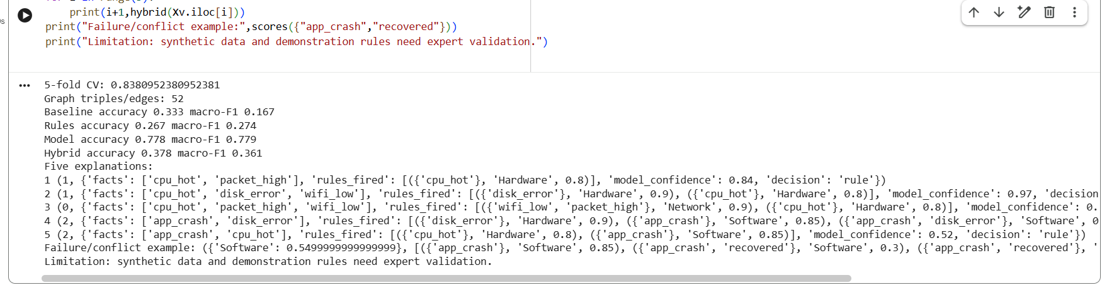

Result
The prototype combined a graph, certainty-factor rules and a Random Forest model. Four systems were evaluated and sample explanations and a failure case were reported.

Viva Questions and Answers
Why combine graph, rules and ML?
The graph stores relationships, rules encode explicit expert knowledge, and ML learns patterns from examples.
What is a certainty factor?
A numeric strength of support for a conclusion; it is not automatically a calibrated probability.
What if rules and ML disagree?
Use a clearly defined policy. This program gives priority to strong positive rule evidence and otherwise uses the ML prediction.
Why use cross-validation?
It evaluates the model across multiple train-validation splits and gives a more stable estimate.
What are limitations and ethical concerns?
Synthetic data may not reflect real faults; rules can be incomplete and models can be biased. Real use requires validated data and human review.

COMMON LAB EXECUTION INSTRUCTIONS
- Create a separate folder for each experiment and save the corresponding program as experiment1.py, experiment2.py, etc.
- Open Command Prompt or PowerShell in that folder.
- Install packages once with: python -m pip install pandas matplotlib networkx scipy scikit-learn rdflib owlready2
- Run using: python experiment1.py (replace the number as needed).
- Plots open in windows; close each plot window to continue.
- Experiments 1 and 8 create sample CSV files if the instructor files are absent. Replace them with instructor-supplied files for final practical work.
- Experiment 6 may require Java for HermiT. Protégé is an alternative interface.
- Keep output files student_marks_clean.csv, university.owl and knowledge_graph.ttl with the record.
Note: Sample outputs are representative. Exact statistics depend on the input dataset, user answers and installed library versions. For Experiment 5, run each consultation separately and answer the prompts.

